Option 1: To complete on a phone, computer, or another device (no printer required). Be careful because the system does time-out after five minutes of inactivity and does NOT save your progress.
- Click on this link (you will be brought to the online system to complete the ASQ-3 & ASQ-SE) (SPANISH link)
- Enter your child's birthday, weeks premature, and click on “I am screening my child today”, then click submit at the bottom of the page.
- Review the skills online and try each with your child.
- Enter your child’s responses into the online system.
- Click “submit” when you have finished the screener.
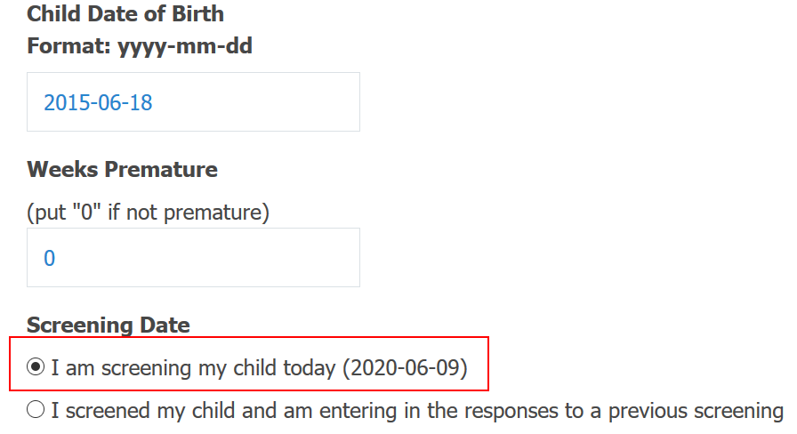

Option 2: Print out the screener and enter your child’s responses after it is completed.
- Enter your child’s information as you would in Option 1. The next screen will come up and you will need to print the questionnaire to record the answers on the paper form. Then enter this data and into the online system. The system does time out after 5 minutes of inactivity.
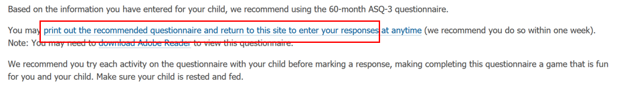
- Once you complete the questionnaire with your child you will go back to this link (SPANISH link) again, enter your child’s information, and click on “I screened my child and am entering the responses to a previous screening”.
