PARENT REGISTRATION
HOW DO I SIGN UP?

1. Go to https://zeeland-mi.finalforms.com

2. Click NEW ACCOUNT under the Parent Icon

3. Type your NAME, DATE OF BIRTH and EMAIL, then click REGISTER

4. Check your Email for a FinalForms Email, and click CONFIRM YOUR ACCOUNT in the email text.
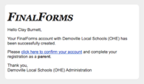
NOTE: You will receive an email within 2 minutes
prompting you to confirm and complete your
registration. If you do not receive an email, check your
spam folder. If you still do not see the FinalForms
email, please email support@finalforms.com

5. Create your new FinalForms password and click CONFIRM ACCOUNT
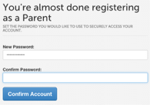

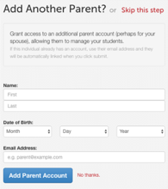
6. You may be asked if you want to grant another.
Parent/Guardian access to your registered students.
Either click SKIP THIS STEP or type the NAME,
DATE OF BIRTH and EMAIL, then click
ADD PARENT ACCOUNT.

7. Your account(s) will be created, you can then click REGISTER STUDENT for your first child.

REGISTERING A STUDENT

WHAT INFO WILL I NEED?
• Basic Medical History & Health Info • Doctor, Dentist & Hospital Information
• Insurance Company & Policy Number • Email Address for BOTH you and your student (if required by your district)

HOW DO I REGISTER MY FIRST STUDENT?

***IMPORTANT*** If you have followed the steps on the previous page, you may Jump to Step 3.

1. Go to https://zeeland-mi.finalforms.com

2. Click LOGIN under the Parent Icon

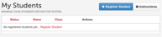
3. Click REGISTER STUDENT

4. Complete the form including the Student’s Legal Name, EMAIL ADDRESS, Date of Birth, Gender, Graduation Year, Home Address and any other information required by your School District, then click CREATE STUDENT
NOTE: A student email address may or may not be required depending on your school district preferences. If so, the email address provided may be used to send reminders to your student.

5. If your student plans to participate in a sport, activity, or club please click the checkbox for each.
Click UPDATE after making your selection.
NOTE: A selection can be changed any time until the registration deadline.

6. Complete each form and sign your full name (e.g. "John Smith") into the Parent Signature field at the bottom of the page. After signing, click SUBMIT FORM and move on to the next form.
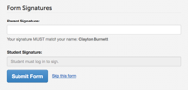

7. When all forms are complete, you will see a “Forms Finished” message.

***IMPORTANT*** If required, an email will automatically be sent to the email address that you provided for your student prompting him/her to sign Student forms requiring his/her signature.

8. Click MY STUDENTS if you are done, or REGISTER ANOTHER STUDENT if you need to add another.

9. At any point in the future, you may login at any time and click the UPDATE FORMS button

